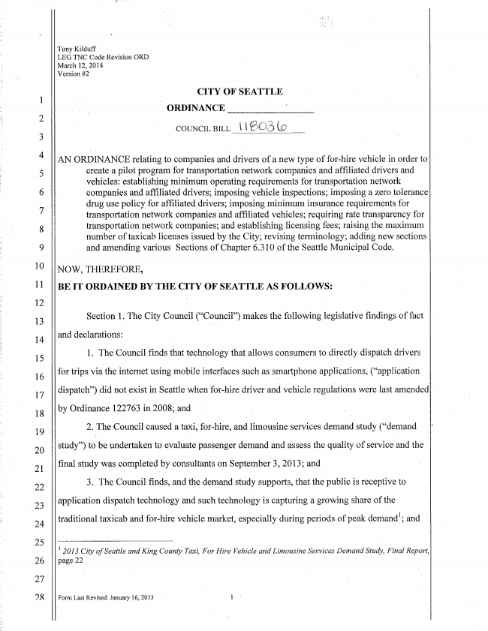
27
Tony Kilduff
LEG TNC Code Revision ORD Maïch El, 2014
Version #2
CITY 0F SEATTLE
ORDINANCE
AN ORDINANCE relating to companies and drivers of a new type of for~hire Vehicie in order to
create a pilot program for transportation network companies and affiliated drivers and Vehicles: establishing minimum operating requirements for transportation neîwork companies and affiliated drivers; imposing vehicle inspections; imposing a zero tolerance drug use policy for affiliated drivers; imposing minimum insurance requirements for transportation network companies and affiliated vehicles; requiring rate transparency for transportation network companies; and establishing licensing fees; raising the maximum number of taxicab licenses issued by the City; revising terminology; adding new sections and amending Various Sections of Chapter 6.310 of the Seattle Municipal Code.
NOW, THEREFORE,
BE IT ORDAÍNED BY THE CITY 0F SEATTLE AS FOLLOWS:
Section 1. The City Council makes the following legislative ñndings of fact
and declarations:
l, The Council finds that technology that allows Consumers to directly dispatch drivers
for trips via-the internet using mobile interfaces such as smartphone applications, (“application
dispatch”) did not exist in Seattle Whenfor-hìre driver and vehicle regulations were last amended
by Ordinance 122763 in 2608; and - i . Y
2. The Council caused a taxi, f0r~hire, and iimousine services demand study (“demand
study”) to be undertaken t0 evaìuate passenger demand and assess the quality of service andthe
ñnal Study Was Completed by Consultants on September 3, 20ì 3; and
-3. The Council finds, and the demand study supports, that thc public is receptive to
application dispatch technology and such technology is capturinga growing share ofthe
traditionaì taxicab and for-hire vehicle market, especialìy during periods of peak demandi; and
I 2013 of Seattle and King Cozmzy Taxi, For Hire Vehicle and Limousine Services Demand Study, F ma! Report. page 22

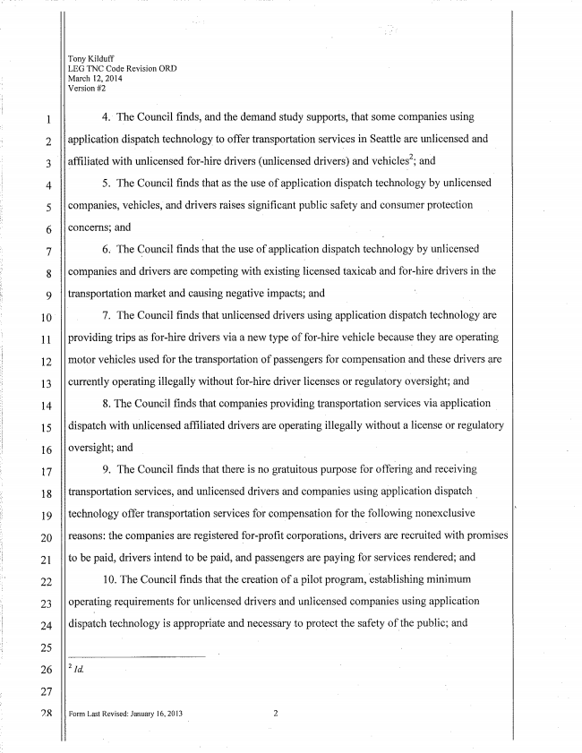
11
12
13
14
15
16
17
18
19
20
2l
22
23
24
25
26
27
'IR
Tony
LEG TNC Code Revision ORD March 52, 2014
Version #2
4.' The Council finds, and the demand study supports, that some companies using
application dispatch technology to offer transportation services in Seattle are unlicensed and
affiliated with unlicensed for­hire drivers (unlicensed drivers) and Vehiclesz; and
5. The Council iinds that as the use of application dispatch technology by unlicensed
companies, vehicles, and drivers raises significant public safety and consumer protection
concerns; and
6. The Counciì finds that the use 0f appiicatìon dispatch technology by unìieensed
companies and drivers are competing with existing licensed taxieab and fer-hire drivers inthe
transportation market and Causing negative impacts; and
7. The Council finds that unlicensed drivers using application dispatch technoìogy are
providing trips as for-hire drivers via a new type of for-hire vehicìe because they are operating
motor vehicles used for the transportation of passengers for compensation and these drivers are
currently operating illegally Without fophire driver licenses or reguìatory oversight; and
8. The Council finds that companies providing transportation sei'viccs via application
dispatch with unlicensed affiliated drivers are operating illegally without a license or regulatory
oversight; and
9. The Council finds that there is no gratuitous purpose for offering and receiving
transportation services, and unìicensed drivers and companies using application dispatch _
technology offer transportation services for compensation for the foilovving nonexciusive
reasons: the companies are registered for-proiìt corporations, drivers are recruited with promises
to be paid, drivers intend to be paid, and passengers are paying for services rendered; and
l0. The Council finds that the creation of a pilot program, Iestablish-ing minimum
Operating requirements for unlicensed drivers and unlicensed companies using application
dispatch technology is appropriate and necessary to protect the safety of the public; and

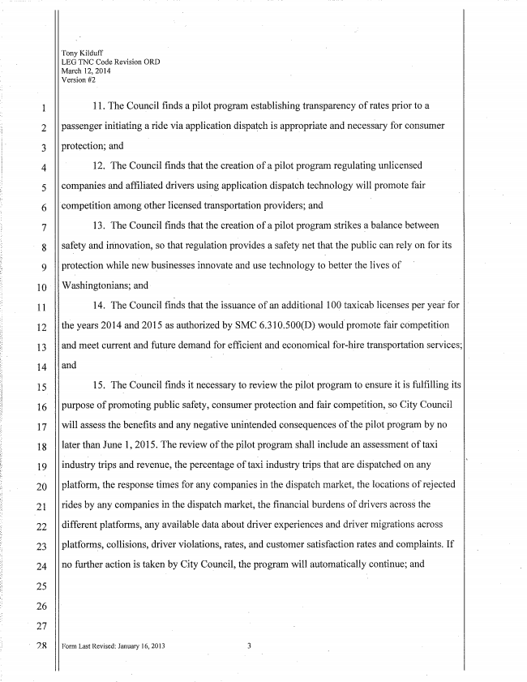
Tony Kilduff
LEG TNC Code Revision ORD March 121 2034
Version #2
ll. The Council finds a pilot program establishing transparency of rates prior to a
passenger initiating a ride Via application dispatch is appropriate and necessary for consumer
protection; and
ÍZ. The Council finds that the Creation of a pilot program regulating unlicensed
companies and afñliated drivers using application dispatch technology will promote fair
­cornpetiîion among other licensed transportation providers; and
13. The Council Íinds that the creation of a pilot program strikes _a balance between
safety and innovation, so that regulation provides a safety not that the public can rely on for its protection while new businesses innovate and use technology to better the ìives of Weshingtonians; and
14. The Council finds that the issuance of an additional i0() taxicab iiccnscs per for
the years 2014 and 2015 as authorized by SMC 6.3i 0.500(D) would promote fair competition
and moet current and 'future demand for efficient' and economical for-hire transportation services;
and
15. The Councii Íinds it necessary to review the piîot program to ensure itis fulñliing its
purpose of proi'noting> publie safety, consumer protection and fair Competition, so City Council
Wiiì assess the benefits and any negative unintended consequences ofthe piiot program by no
later than .inne 1, 2015. The review of the pilot progïam shall include an assessment of taxi
industry trips and revenue, the percentage of tairi industry trips that are dispatched on any
platform, the response times for any companies inthe dispatch market, the ioeations of rejected
rides by any companies inthe dispatch market, the financial burdens of drivers across the
different platforms, any availabìe data about driver experiences and driver migrations across
platforms, collisions, driver violations, rates, and Customer satisfaction rates and compìaints. If
no further action is taken by City Council, the program Wiîl automatically continuo; and
Form Last Revised; January 16, 2013 3

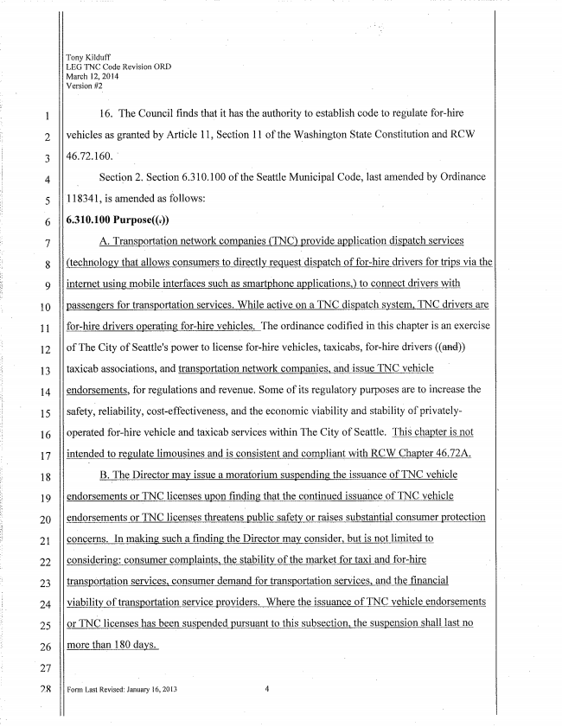
Tony Kilduff
LEG TNC Code Revision ORD March 12, 20M»
Version #2
16. The Council finds that it has the authority to estabìish Code to regulate for-hire
vehicles as granted by Artiole 11, Section 11 of the Washington State Constitution and RCW
46.72.160. ' _
Section 2. Section 6.310100 ofthe Seattle Municipal Code, lasî amended by Ordinance
­118341, is amended as follows:
A. Transportation network companies (TNC) provide application dispatch services
(technologv that allows consumers to directly request dispatch of for-hire drivers for trips via the
internet using1 mobile interfaces such as smartphone applieations,) to connect drivers With
passengers for transportation services. While active en a TNC dispatch system, TNC drivers are
for-hire drivers operating for-hire vehicles. The ordinance codiñed in this chapter is an exercise
of The City of Seattle's power to license for-hire vehicles, taxieabs, fophire drivers
taxioab associations, and transportation network companies, and-issue TNC Vehíeìe
endorsements, for regulations and- revenue. Some of its regulatory purposes are to increase the
Safety,­ reliability, cost-effectiveness, and the economic Viability and Stability of privately
operated for~hìre Vehicle and taxlcab Services Within The City of Seattle. chapter is not
intended to regulate limousines and is consistent and compliant with RCW Chapter 46.72A.
B. The Director may issue a moratorium suspending the issuance of TNC vehicle
endorsements or TNC licenses upon ñnding that the continued issuance of TNC vehioie
endorsements or TNC licenses threatens oubiic safety or raises substantial consumer protection
concerns. In making such a flnding, the Director may consider, but is not limited to
ccnsiderîna: consumer complaints, the stability ofthe market for taxi and for-hire
transportation services„ consumer demand for transportation ­services, andthe financial
viability of transportation service providers. Where the issuance of TNC vehicle endorsements
0r licenses has been Suspended pursuant to this subsection, the suspension shaìl Last no
more than 180 days.
Form Last Revised: January i6, 2013 ¿i

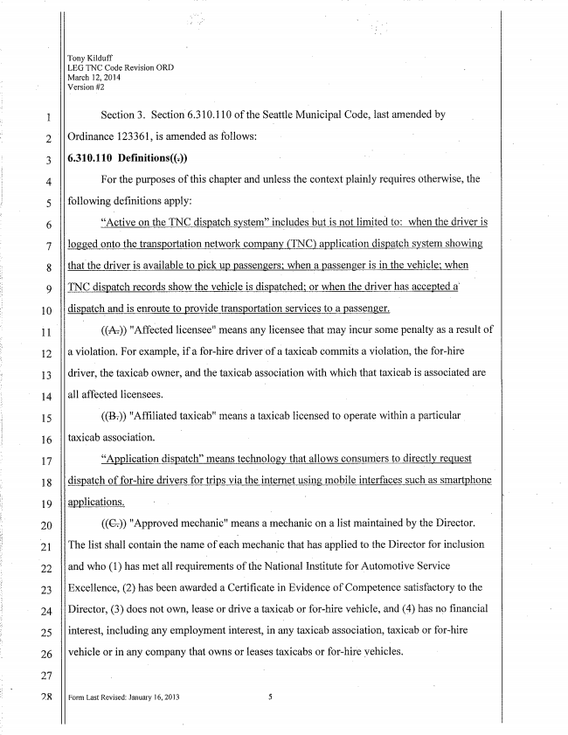
EZ
ES
14
15
16
17
18
19
20
l21
22
23
24
25
26
27
2R
Tony Kilduff
LEG TNC Code Revision ORD March 12, 2034
Version #2
Section 3. Section 6,310,110 ofthe Seattle Municipal Code, last amended by
Ordinance 123361, is amended as foliows:
6.310.110 Definitions((w))
For the purposes of this chapter and uniess the context plainly requires Otherwise, ih@
folìowing deñnitions apply:
“Active on the TNC dispatch system” inçiudes but is not ìimited to: when the driver is
logged onto îhe transportation network company (TNC) application dispatch System showing
that-the driver is available t0 pick up passengers; when a passenger is in the vehicle; when _
TNC dispatch records show the vehicle is dispatched; 0r when the driver has accepted a'
dispatchl and is enroute te provide transportation services to a passenger.
I ((1%)) "Affected licensee" means any licensee that may incui“ some penalty as a resuit of
a Violation. For example, if a driver'ofa taxicab commi-ts a violation, the for-hire
driver, the taxicab owner, and the taxicab association with which that taxicab is associated are
ail affected licensees.
((12%)) "Afñliated taxicab" means a taxìeab licensed to operate Within a particuìar
taxicab association. _
“Application dispatch” means technology that allows consumers to cìirecthr request
dispatch of for~hire drivers for trips via the internet using?,l mobile interfaces Such as smartphone
applications.
((GD “Approved mechanic" means a mechanic on a list maintained by the Director.
The list shall contain the name of each mechanic that has applied to the Directoï for inclusion
and Who (l) has met all requirements ofthe National Institute for Automotive Service
Exceïìence, (2) has been awarded a Certiñeate in Evidence of Competence Satisfactory io the
- Director, (3) does not own, lease 0r drive a taxicab or for-hire vehicle, and (4) has no ñnanciaì
interest, including any employment interest, in any taxicab association, taXìeab or for-hire
vehicle or in any company that owns or leases taxicabs or for-hire yehicles.

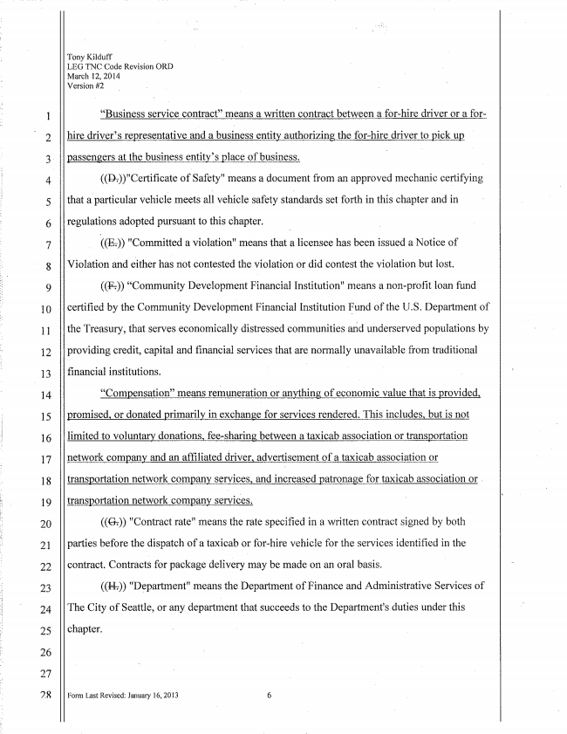
12
13
14
15
16
17
18
19
20
2ï
22
23
24
25
26
27
7.2
Tony
LEG TNC Code Revision ORD March 12, 20l4
Version #2
“Business service Contract” means a Written Contract between a f0r~hire driver or a for
hire driver’s representative and a business entity authorizingl the forßhire driver te pick up
passengers at the business emits/’S piace of business.
((15%))"Certitìcate olf-Safety" means a document from an approved mechanic certifying
that a-partioular Vehicle meets all vehicle safety standards set forth in this chapter and in
regulations adopted pursuant to this chapter.
«E» "Committed a violation“ means that a licensee has been issued a Notice of
Vioîation and either has not Contested the Violation 0r did contest the vioìation but ìost.
“Community Development Financial Institution" means a non»protit loan fund
eertitied bythe Community Development Financial Institution Eurid of the US. Department of
the Treasury, that Serves economically distressed communities and-underserved populations by
providing credit, capital and financial services that are normally unavailable from traditional
financial institutions. I
“Compensation” means remuneration or anything of economic value that is provided,
promised, or donated primarily in exchange for services rendered. This includes, but is not
limited to Voluntary donations, fee-sharing` between a'taxicab association or transportation
network company and an affiliated driver, advertisement of a taxìoab association or
transportation network company services, and increased patronage for taxìeab association or t
transportation network company services.
((61)) "Contract gate" means the rate Speciñed in a Written contract signed by both
parties before the dispatch 01° a taXicab or for-hire vehicle for the services identified in ‘the
comîact. Contracts for package delivery may be made on an oral basis.
((147)) "Department" means the Department of-Finanee and Administrative Services of
The City of Seattle, 0r any department that succeeds to the Departments duties under this
chapter.
Form Last Revised: January 16, 2013 6

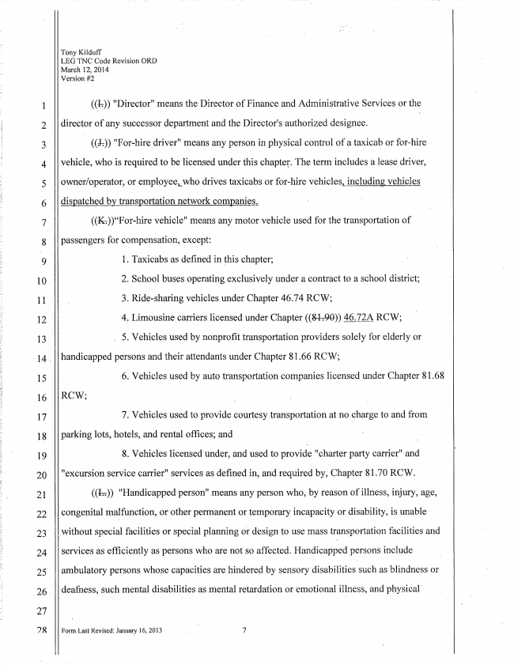
Tony Kilduff
LEG TNC Code Revision ORD March 12, 2014
Version #2
((11)) "Director" means the Director of Finance and Administrative Services or the
director of any successor deparîment and the Director's authorized designee.
l (GQ) "For-hire driver" means any person in physical control of a taxicab or for-hire
vehicle, who is required to be licensed under this chapter. The term incìudes a ieasc driver,
owner/operator, or employeeLWho drives taxicabs 0r Vehicles, including vehicles
dispatched bv transportation network companies.
((1%))“For-hire-vehicle" means any motor vehicle used for the tmnsportation of
passengers 'Por compensation, except:
l. Taxicabs as defined in `this chapter;
2. School buses operating exclusiveìy under a contract to a School district;
3. Ride-sharing vehicles under Chapter 46.74 RCW',
'4. Limousine carriers îîeensed under Chapter ((8%799» m RCW; . 5. Vehicles used by nonproñt transportation providers for elderly or
handicapped persons and their attendants under Chapter _81 .66 RCW;
6. Vehioìes used by auto transportation companies ìioensed under Chapter 8 ì .68
RCW;
7. Vehicles used to provide courtesy transportation at no charge to and from
parking lots, hotels, and rental Offices; and
8. Vehicles licensed under, and used t0 provide "charter party carrier" and
"excursion service carrier“ services as defined in, and required by, Chapter 81.70 RCW.
“Handicapped person" means any person who, by reason of illness, injury, age,
congenital malfunction, or other permanent or temporary incapacity or disability, is unable Without special facilities or special planning of design to use mass transportation facilities and services as efficiently as persons who are not so affected. Handicapped persons include ambulatory persons Whose capacities are hindered by sensoïy disabilities such as blindness or
deafness, Such mental disabilities as mental retardation or emotional illness, and physical'
FGIm Last Revised; January 16, 2013 7

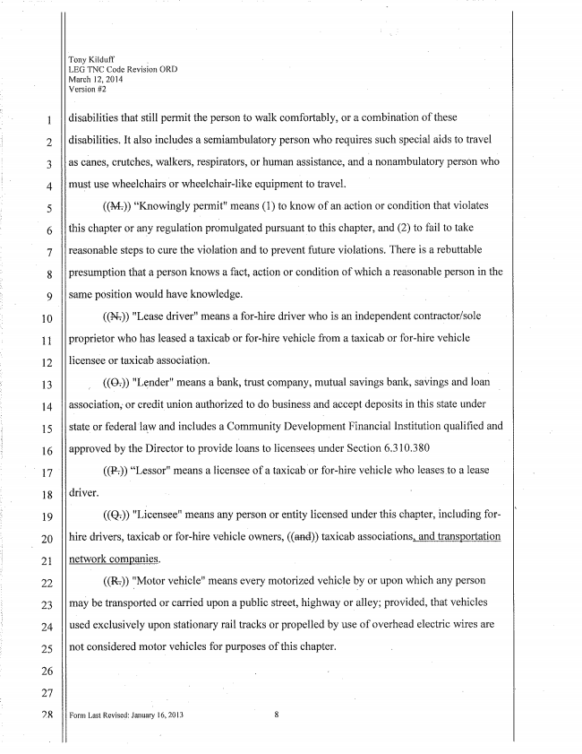
ONOOOHJONM
18
19
20
2i
22
23
24
25
26
27
QR
Tony Kilduff _
LEG TNC Code Revision ORD March 12, 2014
Veïsion #2
disabilities that still permit the person to Walk comfortably, or a combination of these
disabilities. it also includes a semiambulatory person who requires such special aids to travel
as canes, crutches, walkers, respirators, or human assistance, and a nonambuìatory person who
must use Wheelchairs or Wheelchair-like equipment to travel.
((59%)) “Knowineg permit" means (l) to know of an action or condition that violates this chapter or any regulation promulgated pursuant this chapter, and (2) to fail to take
reasonable steps to cute the violation and to prevent future violations. There is a rebuttabie
presumption that a person knows a fact, action or condition of which a reasonable person in the
same position would have knowledge.
((NTD "Lease driver" means a for-hire driver who is an independent contractor/sole
proprietor who has leased a taxicab or for-hire Vehicle from a taxicab or for~hire Vehicle
licensee or taxicab association.
"Lender" means a bank, trust company, mutual savings bank, savings and loan
association,­ or credit union authorized to do business and accept deposits in this state under state or federai'iaw and includes a Community Developinent Financial Institution qualiñed and approved bythe Diïector to provide loans to licensees under Secîion 6.310.380
((1%)) “Lesser” means a iieensee of a taxieablor for-hire Vehicle who ìeasesto a lease
driver. l
I "Licensee" means any person or entity licensed under this chapter, including for
hire drivers, taxicab or for-hire Vehicie owners, «and» taxicab associations, and transportation
network companies.
((RTD 'fMotor vehicle" means every motorized vehicle by or upon which any person
may be transported or Carried upon a public street, highway or alley; pïovided, that vehicles
used exclusively upon Stationary rail tracks or pïopelled by use of overhead eìectrie Wires are
not considered motor vehicles for purposes of this chapter.
Form Last Revised: January I6, 20l3 8

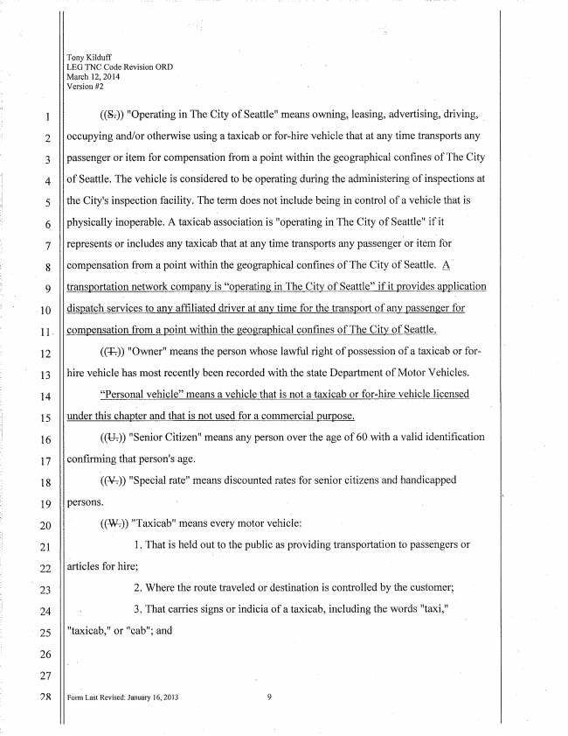
12
13
14
15
16
17
18
19
2()
21
22
Y 23
24
25
26
Tony
LEG TNC Code Revision ORD March 12, 20M
Version #2
«Se» "Operating in The City of Seattle" rneans owning, leasing, advertising,'driving, Y
occupying and/or otherwise using a taXicab or for~hire vehicle that at any time transports any
passenger or item for compensation from a point within the geographical contines of The City of Seattle. The Vehicle is considered to be operating during the administering of inspections at
the City‘s inspection facility. The term does not include being in control of a Vehicle that is physically inoperable. A taxicab association is "operating in The City of Seattle" if it
represents or includes any taxicab that at any time transports any passenger-or itemY 'for
compensation from a point Within the geographical confines of The City of Seattle. „A transportation network company is “operating in The City of Seattle" if it provides application
dispatch Services to any afñliated driver at any time for the transpert ofany passenger for
compensation from a point Within the geographical conñnes of The City of Seattle.
"Owner" means the person Whose lawful right of possession of a taxieab or for~
hire vehicle has most recently been recorded with the state Department of Motor Vehicles.
“Personal vehicle” means a vehicle that is not a taxicab or for-hire vehicle ìicensed
under this chapter and that is not used for a commercial purpose,
((1%)) "Senior Citizen" meansany person over the age of 60 with a valid identiñcation conñrming that person's age. Y l
((3%)) "Special rate“ means discounted rates for senior citizens and handicapped persons.
((3%)) "Taxicab" means everyv motor vehioie:
1. That is held out to the pubiie as providing transportation to passengefs or àrtioles for hire; l
2. Where the route traveled or destination is oontro'îìed by the customer;
Form Last Revised: Jalwary 16, 2013 9

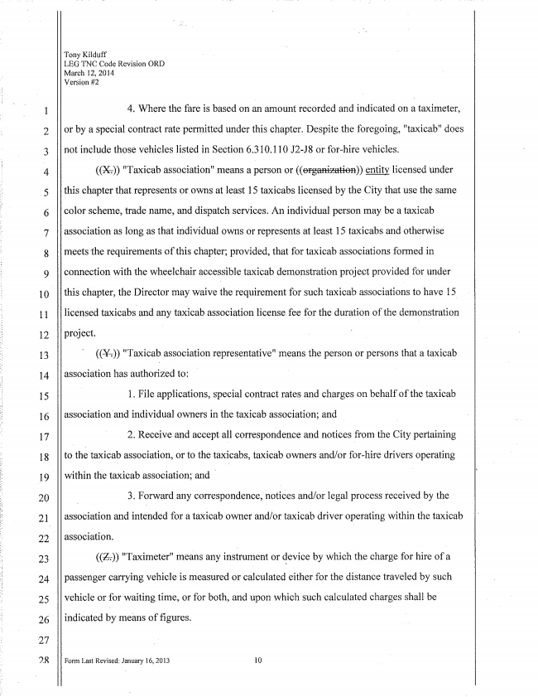
Tony Kilduff
LEG TNC Code Revision ORD Maïch l2, 2014
Version #2
4. Where the fare is based on an amount recorded and indicated on a taximeter,
or by _a special contract rate permitted under this chapter. Despite the foregoing, "taxicab” does
not include those vehicles listed in Section 6.3101 i() or for-hire vehicles.
((9%)) "Taxicab association“ means a person or (()) my ìicensed under
this chapter that represents or owns at ìeast 15 taxicabs licensed by the City that use the same
color scheme, trade­ name, and dispatch services. An individual person may be a taxicab
association as long as that individual owns or represents at least l5 taxicabs and otherwise
meets requirements ofthìs chapter; provided, that for taxicab associations formed in
connection with the Wheelchair accessible taxicab demonstration project provided for under
this chapter, the Director may waive the requirement for such taxicab associations to have 15
licensed taxicabs and any taxicab association license fee for the duration ofthe demonstration
project.
((51%)) "Taxicab association representative" means the person or persons that a taxicab
association nas authorized to:
1. File applications, special contract rates and charges on behalfof the taxicab
association land individual owners in the taxicab association; and
2. Receive and accept all correspondence and notices from the City pertaining
tothe taxicab association, orto the taxieabs, taxicab owners and/or for-hire­ drivers operating
Within the taxìcab association; and Y
3. Forward any correspondence, notices and/or process received by the
association and intended for a taxicab owner and/or taxicab driver operating Within the taxicab
association.
((171)) "Taximeter" means any insirument or device by which the charge for hire passenger carrying vehicle is measured or calculated either for the distance traveled by Such
vehicle or for Waiting time, or for both, and upon which such calculated charges shall ‘oe
indióated by means of Í'lgures.
Form Last Revised: January 16, 2013 l0

